Asymmetric DCC correlation: NZDUSD and USDCAD
Method 10 / GARCH(1,1) + Cappiello-Engle-Sheppard ADCC / Alpari D1 full available history

Study setup
Logical pair: NZDUSD , USDCAD
Broker symbols: NZDUSD_i , USDCAD_i
Snapshot: 2026-11-03_majors_alpari_D1
Timeframe: D1
Matched return window: 1999-01-05 to 2026-11-02 (UTC bar dates)
Matched return count n: 7190
Dropped unfinished last bar dated 2026-11-03 UTC after a tick-volume check against the prior complete day.
NZDUSD GARCH(1,1): mu=0.000000, omega=0.004961, alpha=0.040841, beta=0.950110
USDCAD GARCH(1,1): mu=-0.000004, omega=0.001257, alpha=0.043703, beta=0.951156
ADCC: a=0.015037, b=0.983083, g=0.000000, a+b+g/2=0.998120
Nested DCC (g=0): a=0.015037, b=0.983083
Negative shock: n = min(z, 0) in broker quote direction (not inverted)
Burn-in ignored in path summaries and chart: first 60 updates
Complete matched rows (Excel): NZDUSD-USDCAD_ADCC_D1.xlsx
Complete matched rows (HTML table): NZDUSD-USDCAD_ADCC_D1_data.html

Method carried forward
Asymmetric DCC extends Engle DCC with an extra term on joint negative standardised shocks. Each matched daily log return of close, ln(close_t / close_t-1), is first filtered by a constant-mean GARCH(1,1). Then z = residual / sigma and n = min(z, 0). The Cappiello-Engle-Sheppard recursion uses A = (1-a-b) Q_bar - g N_bar with N_bar = mean(n n'). Quotes are not inverted, so a negative shock is a negative log return in the broker quote. Nested symmetric DCC (g = 0) is fit on the same z path for comparison. Constraints: a,b,g >= 0 and a + b + g/2 < 1. Path summaries ignore the first 60 updates. The headline is latest ADCC rho. Pearson r is a side check only. This is not a cause, lead, or trading signal.

Results
Latest ADCC rho: -0.508162
Latest nested DCC rho: -0.508162
Post-burn-in ADCC path (n=7130): mean=-0.542292, median=-0.558174, min=-0.815884, max=-0.093664, std=0.134957
Share of post-burn-in days with |rho| >= 0.4: 83.11%; |rho| >= 0.7: 10.48%
Same-sample Pearson r: -0.587831
ADCC minus r: 0.079669
ADCC minus nested DCC: -0.000000

Conclusion
Over 7190 matched daily log-return rows for NZDUSD and USDCAD (broker quote directions unchanged), latest ADCC rho is -0.5082 (negative, moderate conditional linear link in this sample) with fitted a=0.0150, b=0.9831, g=0.0000. Nested symmetric DCC latest rho is -0.5082 (ADCC minus DCC = -0.0000). After a 60-day burn-in, path mean is -0.5423 and std is 0.1350. Same-sample Pearson r is -0.5878 (ADCC minus r = 0.0797). This does not establish cause, lead-lag, or a lasting trading rule.

Charts
Daily closes

Daily log returns
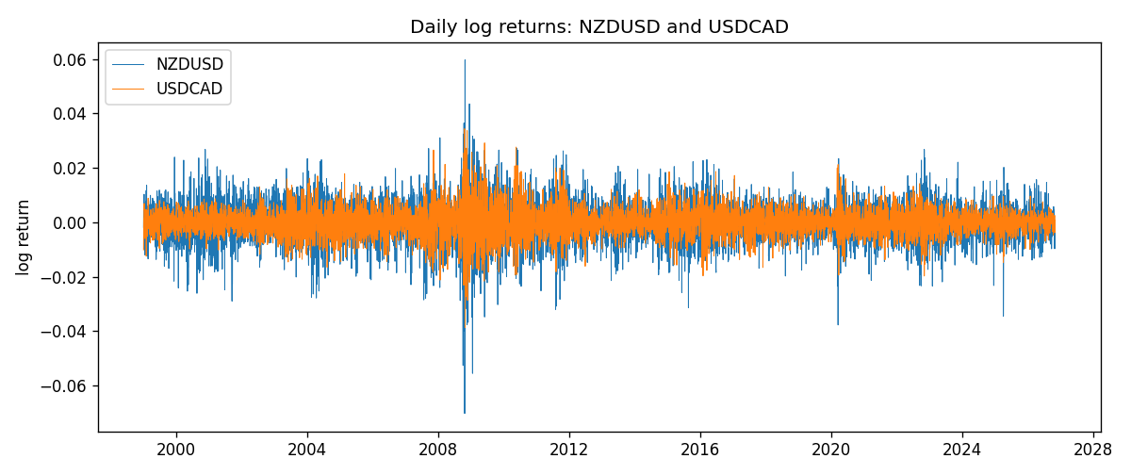
ADCC rho path with nested DCC and Pearson r
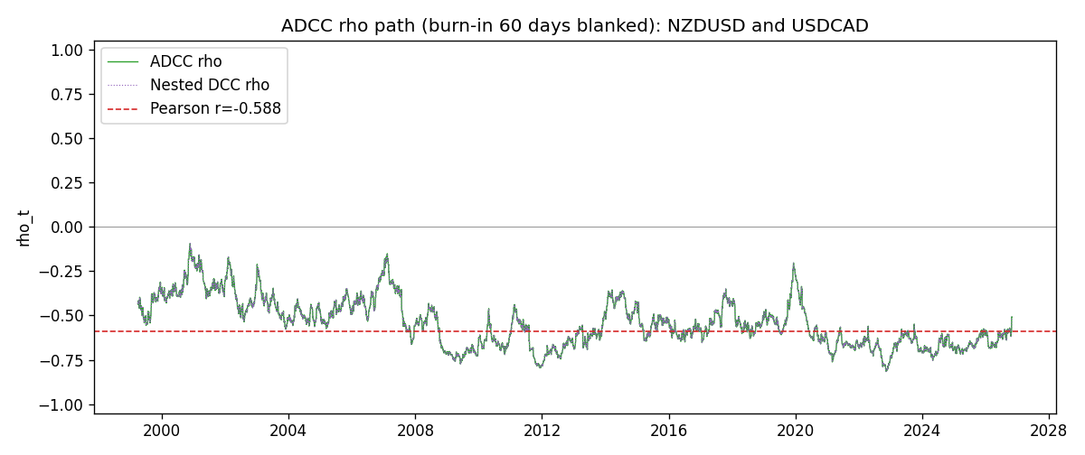

Data report
Every matched row that entered the ADCC recursion is stored in the sibling Excel workbook named NZDUSD-USDCAD_ADCC_D1.xlsx. Embedding all rows as a Word table is impractical at this length; the Word file holds the column list, column summaries, and the first and last 15 matched rows.
Columns: time, NZDUSD_open, USDCAD_open, NZDUSD_high, USDCAD_high, NZDUSD_low, USDCAD_low, NZDUSD_close, USDCAD_close, NZDUSD_tick_volume, USDCAD_tick_volume, NZDUSD_spread, USDCAD_spread, NZDUSD_real_volume, USDCAD_real_volume, NZDUSD_log_return, USDCAD_log_return, NZDUSD_sigma, USDCAD_sigma, NZDUSD_z, USDCAD_z, NZDUSD_n, USDCAD_n, q11, q22, q12, rho_adcc, rho_dcc
Column summaries (matched calculation rows)
column | count | mean | std | min | 25% | 50% | 75% | max
NZDUSD_open | 7190 | 0.6563919 | 0.10821436 | 0.3913 | 0.5912925 | 0.6684 | 0.7249075 | 0.88218
USDCAD_open | 7190 | 1.2668559 | 0.16897553 | 0.9168 | 1.118445 | 1.298545 | 1.37213 | 1.6183
NZDUSD_high | 7190 | 0.66030697 | 0.10871111 | 0.3961 | 0.5947025 | 0.67202 | 0.72936 | 0.88421
USDCAD_high | 7190 | 1.2717549 | 0.16892987 | 0.9336 | 1.122975 | 1.30394 | 1.37655 | 1.619
NZDUSD_low | 7190 | 0.65270307 | 0.10781082 | 0.3897 | 0.5880525 | 0.664185 | 0.720965 | 0.87988
USDCAD_low | 7190 | 1.2623003 | 0.16901312 | 0.9056 | 1.114125 | 1.293585 | 1.36785 | 1.6102
NZDUSD_close | 7190 | 0.65646372 | 0.10821182 | 0.3907 | 0.5915625 | 0.66842 | 0.725015 | 0.8822
USDCAD_close | 7190 | 1.266877 | 0.16895077 | 0.916 | 1.118165 | 1.298615 | 1.372425 | 1.6137
NZDUSD_tick_volume | 7190 | 68672.777 | 123109.57 | 16 | 5561.25 | 33864.5 | 58508 | 1127682
USDCAD_tick_volume | 7190 | 80995.8 | 147287.89 | 37 | 5534 | 40938 | 71622.5 | 1410818
NZDUSD_spread | 7190 | 30.299444 | 25.655426 | 0 | 9 | 17 | 50 | 80
USDCAD_spread | 7190 | 23.448679 | 18.267866 | 0 | 9 | 17 | 40 | 60
NZDUSD_real_volume | 7190 | 1.6692087e+10 | 8.4955308e+10 | 0 | 0 | 0 | 0 | 2.705649e+12
USDCAD_real_volume | 7190 | 1.8371592e+10 | 9.6675129e+10 | 0 | 0 | 0 | 0 | 2.5751613e+12
NZDUSD_log_return | 7190 | 6.02e-06 | 0.00764513 | -0.07027433 | -0.00425619 | 0.00022347 | 0.00457637 | 0.05966839
USDCAD_log_return | 7190 | -9.38e-06 | 0.0051433 | -0.03859748 | -0.00283202 | 5.381e-05 | 0.00272817 | 0.03436319
NZDUSD_sigma | 7190 | 0.00728682 | 0.0021722 | 0.00438984 | 0.00595468 | 0.00669641 | 0.00804191 | 0.02526221
USDCAD_sigma | 7190 | 0.00479404 | 0.00181451 | 0.0025086 | 0.00365477 | 0.00435556 | 0.00535435 | 0.0185305
NZDUSD_z | 7190 | -0.00229057 | 1.0000717 | -5.6191746 | -0.63013359 | 0.03284573 | 0.64644398 | 4.2840273
USDCAD_z | 7190 | 0.00188001 | 1.0000915 | -4.0722206 | -0.6275067 | 0.0112032 | 0.61255652 | 6.4164912
NZDUSD_n | 7190 | -0.38942719 | 0.61575074 | -5.6191746 | -0.63013359 | 0 | 0 | 0
USDCAD_n | 7190 | -0.38677941 | 0.58807605 | -4.0722206 | -0.6275067 | 0 | 0 | 0
q11 | 7190 | 1.0019411 | 0.14367494 | 0.68399324 | 0.90336921 | 0.97802477 | 1.0748855 | 1.9253539
q22 | 7190 | 1.0016759 | 0.13849285 | 0.69488305 | 0.910845 | 0.98536043 | 1.0681832 | 1.773323
q12 | 7190 | -0.54447923 | 0.1650517 | -1.2201447 | -0.64490676 | -0.54427611 | -0.43194426 | -0.09693191
rho_adcc | 7190 | -0.54157223 | 0.13468337 | -0.81588371 | -0.64940886 | -0.55652182 | -0.44631863 | -0.09366419
rho_dcc | 7190 | -0.54157222 | 0.13468339 | -0.81588386 | -0.6494088 | -0.55652192 | -0.44631869 | -0.093664
First 15 matched rows (selected columns)
time | NZDUSD_log_return | USDCAD_log_return | NZDUSD_z | USDCAD_z | NZDUSD_n | USDCAD_n | q11 | q22 | q12 | rho_adcc | rho_dcc
1999-01-05 | -0.0018597736 | -0.010131666 | -0.316157 | -2.238089 | -0.316157 | -2.238089 | 1 | 1 | -0.54327233 | -0.54327233 | -0.54327233
1999-01-06 | 0.0020455609 | -0.0003306769 | 0.35334117 | -0.066662798 | 0 | -0.066662798 | 0.9864659 | 1.0602846 | -0.52446297 | -0.51281719 | -0.51281716
1999-01-07 | 0.0062963171 | 0.0015202092 | 1.1042846 | 0.31743188 | 0 | 0 | 0.9735351 | 1.0442944 | -0.5169661 | -0.51271353 | -0.5127135
1999-01-08 | -0.00055396548 | -0.0020495197 | -0.096430572 | -0.43480211 | -0.096430572 | -0.43480211 | 0.9772826 | 1.0300232 | -0.50397081 | -0.50230998 | -0.50230993
1999-01-11 | 0.010290425 | -0.0035137769 | 1.8229556 | -0.75934414 | 0 | -0.75934414 | 0.96276959 | 1.0173209 | -0.49583592 | -0.50101163 | -0.50101158
1999-01-12 | -0.0053157489 | 0.0066194721 | -0.89729513 | 1.4455821 | -0.89729513 | 0 | 0.99833318 | 1.0106613 | -0.50928429 | -0.50701373 | -0.50701369
1999-01-13 | -0.0099742238 | 0.0045420214 | -1.6860629 | 0.96893711 | -1.6860629 | 0 | 0.99543123 | 1.026867 | -0.52119487 | -0.51551038 | -0.51551035
1999-01-14 | -0.00018564931 | 0.0069376546 | -0.03019391 | 1.4811554 | -0.03019391 | 0 | 1.0232191 | 1.0254928 | -0.53796509 | -0.52517431 | -0.5251743
1999-01-15 | -0.00074294208 | -0.0056905671 | -0.12310912 | -1.1827501 | -0.12310912 | -1.1827501 | 1.0078029 | 1.0430132 | -0.5305581 | -0.51748797 | -0.51748794
1999-01-18 | -0.0018597736 | 0.00098344542 | -0.31381539 | 0.20346215 | -0.31381539 | 0 | 0.99286163 | 1.0482838 | -0.52041441 | -0.51011196 | -0.51011192
1999-01-19 | 0.0018597736 | 0.002748513 | 0.31891438 | 0.57954581 | 0 | 0 | 0.97942611 | 1.0330524 | -0.51359194 | -0.51058869 | -0.51058866
1999-01-20 | 0.0040793678 | -0.0059646885 | 0.71068812 | -1.2737037 | 0 | -1.2737037 | 0.96626638 | 1.0225067 | -0.50314553 | -0.5061883 | -0.50618826
1999-01-21 | 0.0040627941 | -0.0042823796 | 0.71288148 | -0.90180457 | 0 | -0.90180457 | 0.95939482 | 1.0314839 | -0.50926679 | -0.51193574 | -0.5119357
1999-01-22 | -0.012051689 | 0.0025057712 | -2.1294737 | 0.53090121 | -2.1294737 | 0 | 0.95268645 | 1.0281431 | -0.51133986 | -0.5166636 | -0.51666357
1999-01-25 | -0.0035504102 | 0.00085579808 | -0.58479472 | 0.18468293 | -0.58479472 | 0 | 1.006638 | 1.0168682 | -0.52071088 | -0.51466858 | -0.51466856
Last 15 matched rows (selected columns)
time | NZDUSD_log_return | USDCAD_log_return | NZDUSD_z | USDCAD_z | NZDUSD_n | USDCAD_n | q11 | q22 | q12 | rho_adcc | rho_dcc
2026-10-13 | 0.0047326165 | -0.0046395653 | 0.96099915 | -1.6067049 | 0 | -1.6067049 | 0.77304693 | 0.81929733 | -0.46191824 | -0.58041872 | -0.58041861
2026-10-14 | -0.0037306483 | 0.0015184751 | -0.75442531 | 0.50777396 | -0.75442531 | 0 | 0.77573617 | 0.84613548 | -0.47834319 | -0.59042213 | -0.59042204
2026-10-15 | 0.0047634855 | -0.0036101503 | 0.96636068 | -1.2177234 | 0 | -1.2177234 | 0.77305133 | 0.83757831 | -0.47703271 | -0.59283151 | -0.59283143
2026-10-16 | 0.0057501001 | -0.0034322068 | 1.1614904 | -1.1405007 | 0 | -1.1405007 | 0.77589588 | 0.84758664 | -0.4876791 | -0.60136808 | -0.60136801
2026-10-19 | 0.0018917133 | -0.0018835331 | 0.37734321 | -0.61862056 | 0 | -0.61862056 | 0.78493583 | 0.85468727 | -0.5003697 | -0.61090026 | -0.6109002
2026-10-20 | 0.0037199341 | -0.0037066008 | 0.75121946 | -1.2299349 | 0 | -1.2299349 | 0.77567796 | 0.84786292 | -0.49643636 | -0.61215308 | -0.61215302
2026-10-21 | 0.0030923331 | -0.00084691787 | 0.62655235 | -0.27586774 | 0 | -0.27586774 | 0.77292152 | 0.85814672 | -0.50295299 | -0.61755966 | -0.61755961
2026-10-22 | -0.0033035227 | -0.0026307268 | -0.67390697 | -0.87344459 | -0.67390697 | -0.87344459 | 0.76762889 | 0.84665364 | -0.4980649 | -0.6178135 | -0.61781345
2026-10-23 | 0.0030929853 | 2.85545e-05 | 0.63435567 | 0.010666544 | 0 | 0 | 0.76335182 | 0.84568253 | -0.48180923 | -0.5996655 | -0.59966543
2026-10-26 | -0.0028993932 | 5.7106554e-05 | -0.59843231 | 0.020528255 | -0.59843231 | 0 | 0.75836903 | 0.83325763 | -0.47457797 | -0.59700454 | -0.59700446
2026-10-27 | -0.00026399852 | 0.0025379458 | -0.054879914 | 0.87597682 | -0.054879914 | 0 | 0.7528046 | 0.82104755 | -0.46775552 | -0.59496803 | -0.59496795
2026-10-28 | -0.0097283914 | -0.0038379274 | -2.0515298 | -1.3218841 | -2.0515298 | -1.3218841 | 0.74199447 | 0.82057622 | -0.46158664 | -0.59155269 | -0.5915526
2026-10-29 | 0.00062190714 | -0.00011436495 | 0.12261108 | -0.037432149 | 0 | -0.037432149 | 0.79460988 | 0.8348499 | -0.41402022 | -0.50832372 | -0.50832356
2026-10-30 | 0.00019537668 | -0.0010298736 | 0.039108785 | -0.3526805 | 0 | -0.3526805 | 0.78327332 | 0.82262762 | -0.40810649 | -0.5084113 | -0.50841114
2026-11-02 | -0.0025962955 | 0.00061519094 | -0.52769207 | 0.21569866 | -0.52769207 | 0 | 0.77192547 | 0.8124614 | -0.4024312 | -0.50816247 | -0.50816231

